Courier Service Web Application
Narrative Use Cases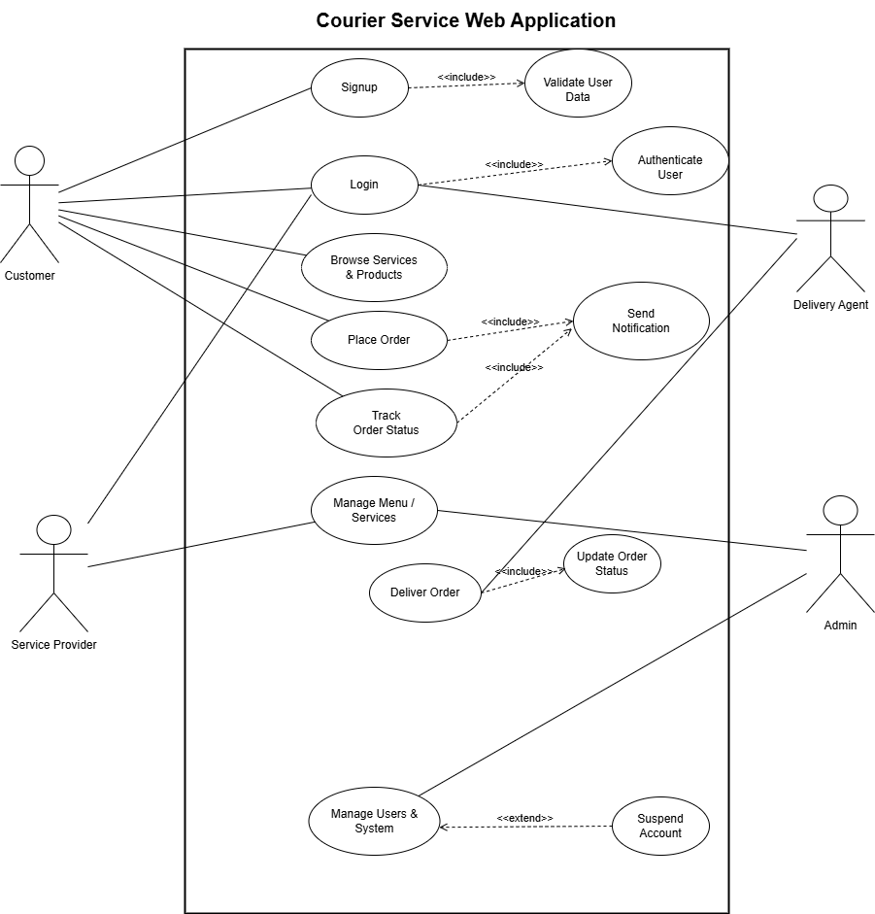

UC1: Customer Signup
Actors:
- Customer
Description:
This use case describes how a new customer creates an account in the QuickDeliver system. Signup is available only for customers; other roles are created by the Admin.
Preconditions:
- The customer does not already have an account.
- The customer has access to the signup page.
Main Flow:
- The customer selects the Sign Up option from the authentication page.
- The system displays the signup form.
- The customer enters full name, email, and password.
- The system sends the data to the backend for validation.
- The system creates a new customer account with role = Customer.
- The system automatically logs in the customer.
- The system redirects the customer to the Customer Dashboard.
Alternative Flow (Exceptions):
- 4a. Email already exists
  - The system rejects the request and displays an error message.
- 4b. Missing or invalid data
  - The system displays validation errors and requests correction.
Postconditions:
- A new customer account is created and stored in the system.
- The customer is logged in and can access customer features.

UC2: Login
Actors:
- Customer
- Admin
- Service Offeror
- Courier
Description:
This use case allows registered users to log into the system and access their role-specific dashboard.
Preconditions:
- The user has an existing account.
Main Flow:
- The user selects the Login option.
- The system displays the login form.
- The user enters email and password.
- The system authenticates the credentials.
- The system retrieves the user role.
- The system redirects the user to the appropriate dashboard.
Alternative Flow (Exceptions):
- 4a. Incorrect email or password
  - The system displays an error message.
- 4b. Account does not exist or is inactive
  - The system denies access and shows an error message.
Postconditions:
- The user is logged into the system with access based on their role.

UC3: Browse Products
Actors:
- Customer
Description:
This use case allows customers to view approved products and filter them by category.
Preconditions:
- The customer is logged in.
Main Flow:
- The customer navigates to the Shop Products section.
- The system retrieves approved products from the backend.
- The system displays products with name, price, and category.
- The customer filters products by category (optional).
- The customer views product details.
Alternative Flow (Exceptions):
- 2a. No products available
  - The system displays a message indicating no products are available.
Postconditions:
- The customer views available products.

UC4: Add Product to Cart
Actors:
- Customer
Description:
This use case allows customers to add selected products to their shopping cart.
Preconditions:
- The customer is logged in.
- Approved products exist.
Main Flow:
- The customer clicks Add to Cart on a product.
- The system sends the product ID to the backend.
- The system adds the product to the customer’s cart.
- The system updates and displays the cart.
Alternative Flow (Exceptions):
- 2a. Backend error occurs
  - The system displays an error message.
Postconditions:
- The selected product is stored in the customer’s cart.

UC5: Place Order (Checkout & Payment)
Actors:
- Customer
Description:
This use case allows customers to place an order and choose a payment method.
Preconditions:
- The customer is logged in.
- The cart contains at least one product.
Main Flow:
- The customer selects Checkout.
- The system displays the order summary.
- The customer selects a payment method (Cash or Credit Card).
- The customer confirms the order.
- The system creates a new order.
- The system clears the cart.
- The system displays a payment success message.
Alternative Flow (Exceptions):
- 5a. Order creation fails
  - The system displays an error message.
Postconditions:
- A new order is created and saved.
- The order status is set to Placed.

UC6: Track Orders
Actors:
- Customer
Description:
This use case allows customers to view their past and current orders.
Preconditions:
- The customer is logged in.
Main Flow:
- The customer opens the My Orders section.
- The system retrieves the customer’s orders.
- The system displays order ID, status, payment method, and total price.
Alternative Flow (Exceptions):
- 2a. No orders found
  - The system displays “No orders yet”.
Postconditions:
- The customer views order history and status.

UC7: Manage Products (Service Offeror)
Actors:
- Service Offeror
Description:
This use case allows service offerors to add and manage products that require admin approval.
Preconditions:
- The service offeror is logged in.
Main Flow:
- The service offeror accesses the dashboard.
- The service offeror adds or edits product details.
- The system submits the product with status = Pending.
- The system stores the product for admin review.
Alternative Flow (Exceptions):
- 3a. Invalid product information
  - The system displays validation errors.
Postconditions:
- Product is saved with pending approval status.

UC8: Approve & Manage Products
Actors:
- Admin
Description:
This use case allows the admin to approve, edit, or delete products.
Preconditions:
- The admin is logged in.
Main Flow:
- The admin views pending products.
- The admin approves or rejects products.
- The system updates product status.
- Approved products become visible to customers.
Alternative Flow (Exceptions):
- 3a. Update fails
  - The system displays an error message.
Postconditions:
- Product list is updated in the system.

UC9: Manage Users
Actors:
- Admin
Description:
This use case allows the admin to create and manage system users.
Preconditions:
- The admin is logged in.
Main Flow:
- The admin opens the user management section.
- The admin creates accounts for Admin, Courier, or Service Offeror.
- The system saves the user account.
Alternative Flow (Exceptions):
- 2a. Missing role or invalid data
  - The system displays an error.
Postconditions:
- New user account is created and stored.

UC10: Deliver Order
Actors:
- Courier
Description:
This use case allows couriers to update delivery status.
Preconditions:
- The courier is logged in.
- Orders are available.
Main Flow:
- The courier views active orders.
- The courier picks up an order.
- The courier updates the order status to On the Way.
- The courier delivers the order.
- The courier updates the order status to Delivered.
Alternative Flow (Exceptions):
- 2a. Status update fails
  - The system displays an error message.
Postconditions:
- Order status is updated and visible to the customer.

